**Project Proposal**

My final project will be based on the popular computer game, Valorant, by Riot Games. Valorant is a 5-players versus 5-players tactical first-person shooter. In Valorant, there are 21 agents with specialized abilities for each agent that the player can choose from. Also, there are 7 different maps that randomly assigned to each game played in Valorant as well as 17 different guns the players can choose from. The question of interest for my project would be, what is the best combination that the players can choose from that would result in the highest win rate. This will depend on what combination of agents and guns are the best given the map and whether you are starting from attack or defending side.

I have multiple datasets to help draw my conclusion:

* Attack win rate for each map
* KD (Kill and death), win rate, pick rate, and ACS (average combat score) for each agent
* Kills per match, headshot percentage, and average damage per round for each weapon.

Dataset Example:

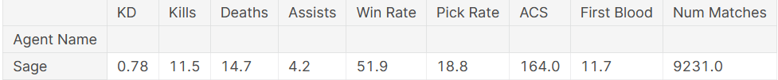

I would like to incorporate machine learning into this project because the data is always changing due to frequent updates to the game, but since I’m not familiar with it yet, I believe a multiple regression model is best for my project even though we haven’t covered that yet in 7014 ☹.

In a similar primary analysis, the analyst gives graphical representation of the most picked agent and average damage per round (ADR) for each agent, then plotted comparing the role type of each agent.

Then a one-way ANOVA is done to compare the means of each role type which proves that at least one mean is different from the others.

There’s also graphical representation of first contact and first contact wins, assists per round (APR), clutch win rate, headshot percentage of each agent for all characteristics. Dataset includes how many agents do most players play and co-occurrence between a player’s most and second most played agents.

The main purpose of this analysis is to use all these datasets which sums up the player stats and predict what agent/role the player plays. First, the analyst split the data into train/test sets with 80/20 proportions. Then, used the training set to train an SVM (support vector machine) model.

**Based on previous data, I want my ML to predict my chances of winning based on my agent, map, placement, duration, avg rank of match, acs, k/d, adr,hs, kast, first kill, first death, mk, econ.**

**Can be used for predicting future val gameplays**